VERTEX FINANCIAL SERVICES DIVISION

COMMITTEE: Bid Approvals Board

DATE: 31 August 2007

REPORT BY: David Edwards - MD Mortgages BU

SUBJECT: Project Hubble (Strategic Omiga Transition Programme)
_______________________________________________________________________________

- Object

To seek approval to incur £100k of capital expenditure, £1.2m of capitalised internal manpower cost and £352k of third party consultancy and technical support to deliver the migration of Omiga to .NET technology over a 12 month period to August 2008

- Recommendation
That approval is granted to commence the project and incur the expenditure.

- Investment Required
Summary
The proposal is to migrate the Omiga core technology to .NET. This will require £100k of capital expenditure, £1.2m of capitalised internal manpower cost and £352k of third party consultancy and technical support to deliver the migration of Omiga to .NET technology over a 12 month period to July 2008.

Background

Omiga is the industry leading independent point of sale and mortgage application processing solution used by a number of leading UK mortgage lenders, including BM Solutions, Mortgage Express, Deutsche Bank, ING Direct and Northern Rock. Revenue generated from the licensing, customisation and support/maintenance of Omiga is:

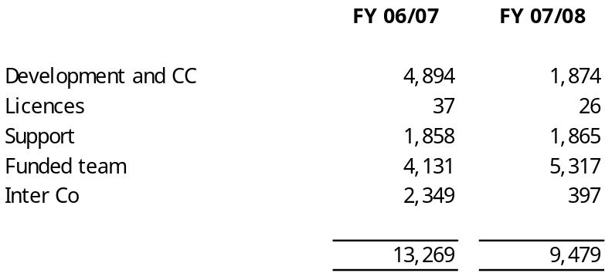

Typical EBITA is 40-45%. The FY 07/08 position shown reflects the recent loss of a number of prospective opportunities including at Nationwide Intermediary systems, the completion of 1a and 1b development at BBG and the ING intermediary development. The inter-company revenue was generated from the delivery of Omiga into the Db Mortgages technical solution.

The Omiga software delivery team currently comprises 67 permanent and 10 contractor heads. The contractors have C++ skills and are specifically deployed to the Northern rock funded team contract.

The last technology refresh took place in 1999 through 2000 with a comprehensive re-write of Omiga onto VB6. Since 2003 we have been aware of plans to replace VB6 and C++ with the .NET equivalents and have elected to follow a step-by-step migration path supported by customer investment. In more recent Omiga customisations the technical architecture has been improved in particular with the development of Web Services and the use of C# for new components.

Current Issues

Omiga is currently built around the Microsoft Windows DNA architecture largely utilising VB6. Microsoft extended support of VB6 ends in April 2008. As a result we have now reached a stage where a wholesale migration/re-write of the remaining VB6 technology is required. In doing this we fully expect to take advantage of the knowledge and experience of other areas of the business (such as The Exchange and 1st Software) as well as being able to utilise existing components of collateral to reduce our overall development time.

The migration to a .NET technology base is essential for the continued future success of both the mortgage software and outsourcing business. We are receiving clear messages from both existing clients (ING) and potential clients (GMAC) that they require Omiga to move off the unsupported VB6 development toolset in 2008. We recently bid for the sale of Omiga to Nationwide. The essential requirement of Nationwide was a .NET based solution. Although we positioned a plan to migrate Omiga to .NET Nationwide decided to select a competitor product which is being marketed as leading edge technology and more flexible due its use of SOA. These same points were also made by Lehmans – an opportunity we also lost in Q4 2006.

- Proposed change

The proposal is to refresh the Omiga technology by removing completely the obsolete VB6 technology; this will be achieved through a blend of porting code and re-writing of key components and will take an estimated 12 months of elapsed time.

Over the last two Omiga customisations (ING and DB) we have taken steps forward with the Omiga technical architecture and in particular with the introduction of Web Services and the use of C# for new and suitable developments, all of which have been funded through (direct or indirect) customer investment.

The migration is currently being considered on the basis of using a third party specialist company, Artinsoft, to perform a significant part of the Migration. Artinsoft are an offshore company who specialise in migration to .NET and are Microsoft’s recommended global partner for this activity. Artinsoft were commissioned to perform an assessment of the Omiga software and provide a fixed price quote for conducting the work. They have completed this and have advised that they regard our software as a relatively simple project with little complexity. Their quote (£352k) is included in the costing.

The Vertex resource is being used to do some preliminary preparation work that requires
- customised changes to Omiga,
- creation of the regression test packs,
- participation in testing and fault resolution as well as overall management of the activity.

Mortgage experience and knowledge of Omiga is essential for much of this work. The programme of work will take into account the movement of the code for ongoing enhancements which is expected to occur in parallel with the migration activity so there is also an element of refresh and retest required. Appendix A contains a detailed outline of the project.

Project development costs amounting to £1.236m are to be capitalised and (upon completion of the project) amortised over a 5 year period against future Omiga profit streams.
- Benefits arising
The project will deliver:
  - A strategic solution capable of implementation for future customers.
  - An upgrade strategy for existing customers such as Egg, Db Mortgages, ING and BM Solutions
  - Better collaboration across development teams through the use of new development tools for .NET
  - Increased productivity for developers through the automation of many of the basic supporting tasks and the inclusion of base classes and templates
  - Clear direction and commitment to staff re the Omiga product and hence their future career paths

- FINANCIAL SUMMARY

Analysis of expenditure

The expenditure to be authorised is summarised as follows:

 | Capital cost |  | Operating  Cost |  |  |  |  | 0607  FY | 0708  FY | 0809  FY+
 | £k |  |  |  |  |  |  | £k | £k | £k
Furniture
Non IT equipment |  |  | Depreciation |  |  |  |  | - | 224 | 337
Consultancy | 352 |  | Other Opex |  |  |  |  | - | - | -
IT hardware | 100 |  | Total |  |  |  |  | - | 224 | 337
Telephony equipment
Software licence |  |  | Asset Life |  |  |  |  | 5 | Years
Consultants/contractors |  |  | Go live estimate |  |  |  |  | Jun 08
Vertex resource | 1236 |  | Cost centre
Total | 1688

The proposed manpower plan for delivering the project is set out in Appendix E. The project costs include;

- a 30% contingency for additional manpower effort covering any issues which are identified during the project; the project contingency value is £265k
- a fixed price quotation from Artinsoft for USD699k (payment details are set out in Appendix B1)
- a capital equipment requirement of £100k (details are set out in Appendix B2)

All Software delivery manpower has been costed at incremental salary rates only and do not include any capitalisation of business overheads. The average man day rate used is £220 (equivalent to a fully loaded annual remuneration of £48k).

The VFS FTE plan to support the .NET migration is:

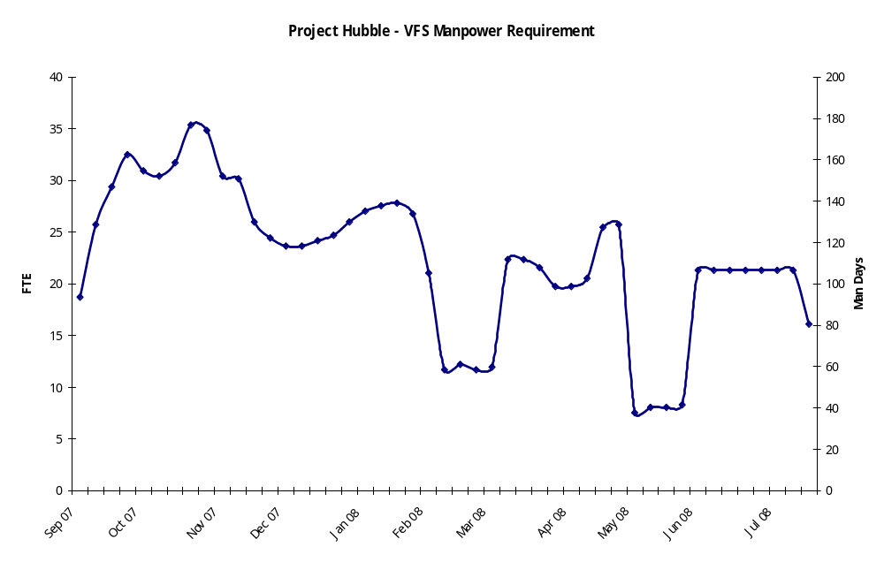

On the assumption of a September 2007 start date, the planned expenditure is forecast to be £1.14m in FY 0708 and £548k in FY 0809.

Future economic benefit
The project is required to assist in securing our current long term Omiga users whilst additionally providing a stronger and more technically robust product to bid additional opportunities.
Whilst it is difficult to precisely size the opportunities:
  - ING have a stated requirement to be on a .NET platform as soon as possible
  - It is likely that the current BBG bid will identify .NET as a requirement. It is considered to present the Mortgages BU with some difficulty as customers generally believe this should be a core part of product development. This would be particularly true of ING who I believe the migration to be an inherent part of the product strategy
- High Street Home Loans are looking for a front end system and VFS is in the tender process. Their requirements include a .NET based solution

From a competitive viewpoint, it is already evident from Project Shackleton that other bidders have an evolved .NET strategy which will be harmful to Omiga as a preferred solution should the migration work be postponed or deferred.
A summary 5 year plan P&L account is set out in Appendix C together with a cash flow statement in Appendix D. This shows that the migration project would have an illustrative payback period of 2.3 years and an IRR in excess of 51%. The average annual Return on Capital Employed is c30%.
If the project was not approved then it is considered that there would be a continual and increasing deterioration in Omiga revenues over a 2-3 year period and this would be exacerbated by a rapid deterioration in the existing employee skill set as it would be perceived that there would be no career path or future development of the application. Should this occur then the potential loss of to Vertex of annualised EBITA arising from Omiga would be in the order of £4-4.5m.

- Sensitivities
The costings above include a 30% internal manpower contingency to cover any issues that may arise as the migration path develops.
If revenues were to fall by 25% then the payback would extend to an estimated 2.9 years.
If revenues were to increase by 10% in the early years then the payback period would fall to 2.1 years.
- Budget summary
The Mortgages BU budget for FY 07/08 included £1m capital expenditure for “Roadmap” development. It is proposed to utilise this budget for the .NET migration and to include the balance of project expenditure in the 0809 budget.

- SUMMARY OF REJECTED ALTERNATIVES

There are three possible alternative approaches;

- Do nothing
The alternative is to keep the existing services going. This will provide benefit through cost avoidance however we predict that within three years not only our current software offering but also our outsourcing proposition will be comprehensively outdated and we will have lost all of our ability to meet new or potentially existing customer needs and demands.

- Full rewrite

The downside to a migration approach compared to a full re-write is that we will have developed a “works with” rather than “designed for” solution. This migration approach may be an issue for more “technically principled” customers, although we believe the business functionality of the Omiga product will overcome any technical objections (the one constant in software development is technical change) and so this should not be the main focus for prospective Omiga customers.

- Seek Customer funding

The migration to .NET could be undertaken as part of a new customer implementation if sufficient planning and technical investigation work has taken place beforehand and sufficient timescales exist to undertake not only the conversion but also any customisation required by the client, however, it would significantly impact the timelines for delivery of the customer system which could put at risk our ability to win the deal

- RISKS AND MITIGATION

The table below details the risks in completing the project and the proposed mitigation:

Risk | Mitigation
Resource constraints to work on this project. There is a risk that ‘business as usual’ work will require these resources resulting in an impact to the schedule. | The Mortgages Senior Management Team to monitor and agree impact of other priority work. Overtime could be worked to reduce any impact.  Consider temporary use of staff from other areas of Vertex or use of outsourcing/contract staff, to keep projects on target.  External resources to provide incremental capability
Key resources on the programme leave the company, leading to delays in the schedule. | Succession planning in place for key staff. Overtime could be worked to reduce any impact. Consider temporary use of staff from other areas of Vertex or use of outsourcing / contract staff, to keep projects on target.
Use of new technology and approaches, yet to be fully proven in our commercial environment.  Resultant problems could lead to code re-writes or late implementation of other technology. This in turn could cause a cost overrun and also cause the programme to overrun. | Contingency built into the programme.  Microsoft partnership contract is in place. Regular design reviews to be held with Microsoft and any involved partners.  Supervisor to be developed and used as a proving ground for the architecture.
Scope creep or excessive demand for change leading to cost and schedule overrun. | Strong project and configuration control to be in place as with other external development programmes.
Delays incurred from Internal Governance will lead to schedule delays and possible impact on overall costs. | Internal Governance to be given early notification of requirements. Regular meetings to be held with Internal Governance to enable early notification of changes
Performance of the new system is inadequate. | Testing cycles to include a level of performance and concurrent usage. Performance testing will be undertaken on the live service before it is ‘switched on’.

- TIMETABLE
The outline timetable for the project is as follows;

Milestone / Deliverable | Target Date
Project Start | September 2007
Infrastructure and development environments set up | October 2007
Omiga GUI Migrated to ASP.Net | November 2007
Provide code to Artinsoft | December 2007
Functional Test Scripts provided to Artinsoft (Automation) | January 2008
Supervisor re-architect complete | April 2008
Functional equivalence of Omiga in C# | May 2008
Performance tuning complete | June 2008
Product VB6 change Nov-June applied in C# to code | August 2008
End state designed and Proof of Concept complete | August 2008

Appendix A – Internal Manpower Tasks

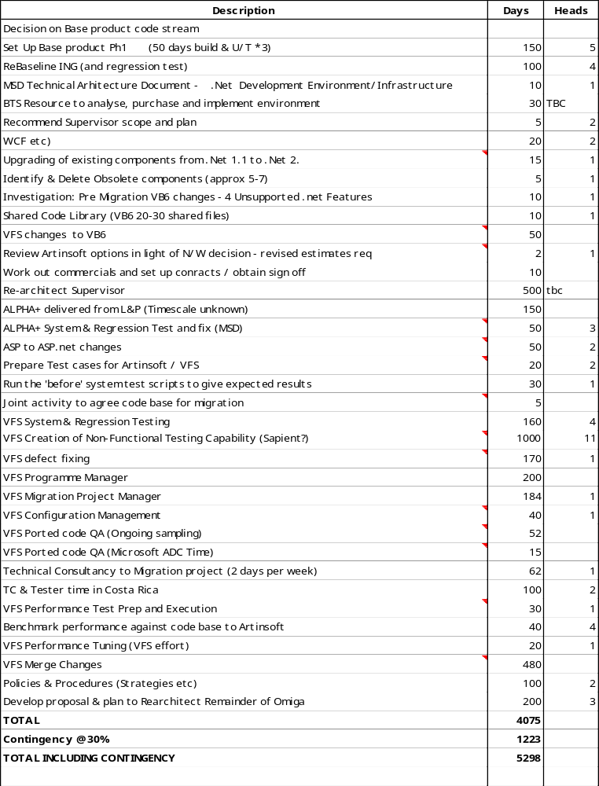
APPENDIX B 1 – Artinsoft Quotation

Deliverable | Price | Date
VBUC License | $89,999 | Project Start Date
VBUC Customization and Omiga Green Code | $27,798 | 1.5 months after Project Start Date
Compiling Source Code | $232,841 | 2 months after VBUC Customization
First Application Build for QA | $116,421 | 1 month after Compiling Source Code
Functional Equivalence | $232,841 | 2 months after the first Build for QA has been delivered
Total | $699,900

Appendix B2 – Capital Equipment

Omiga.NET Porting Infrastructure Costs | Capex | Opex
VFSD Build PC | £ 2,500 | £ 600
VFSD Developer PC - Post Port Development | £ 12,000 | £ 3,000
SAN - Space for SourceSafe and ESX Images | £ 9,000 | £ 2,000
Blade Infrastructure Requirements | £ 20,000 | £ 5,000
.NET DB Server | £ 6,000 | £ 2,000
Omiga Load Test Web, App and Ingestion | £ 10,000 | £ 2,000
ESX Farm | £ 8,000 | £ 2,000
Citrix Servers - Remote Access | £ 10,000 | £ 2,000
Networking | £ 2,000 | £ 2,000
Total | £ 79,500 | £ 20,600

APPENDIX C – Projected P&L arising from Project

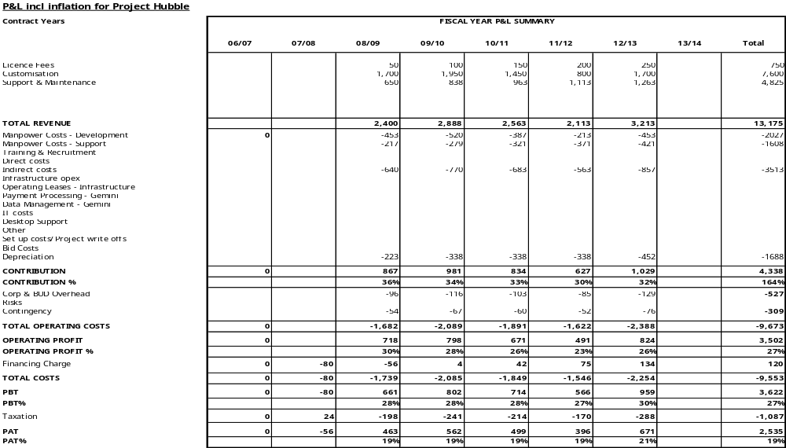
APPENDIX D – Projected Cashflow arising from project

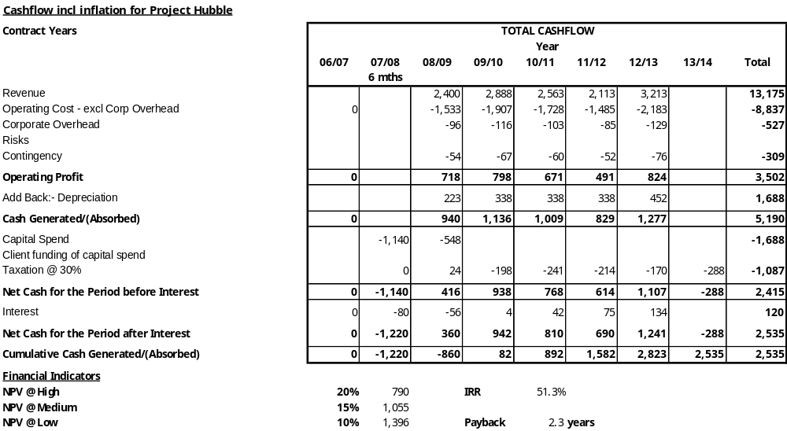
APPENDIX E – PROJECT PLAN
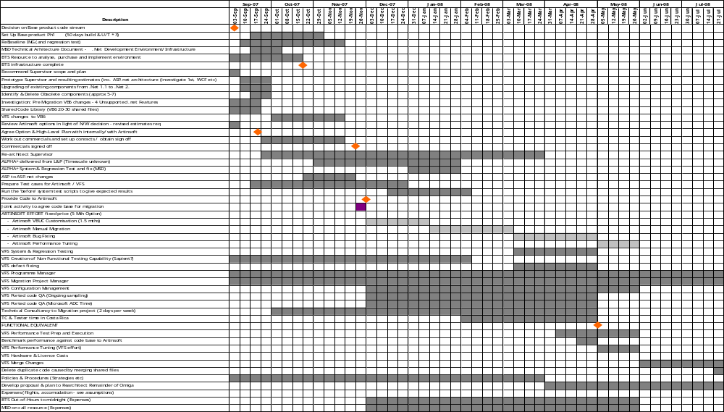
APPENDIX F – Omiga .NET Roadmap

Introduction

This document has been produced in order to outline the high level approach that is being recommended for taking the Omiga technical architecture forward. There is no doubt as to the level of business functionality and business benefit that the current Omiga solution provides to its customers, nor to the future sales opportunities that exist. However, the underlying technology base which accounts for the much of the underlying middle and data tier code base (VB6) is due to have its development support phased out by Microsoft in March 2008. Hence there is a need for us to ensure that any new developments within the Omiga solution are future proofed. Recently, we have seen an increasing need to demonstrate our commitment and plans for migration to the current Microsoft technology platform .NET.

This document recommends that a migration investigation work package takes place to review and consider some of the granular options that are available and make final recommendations for the migration of Omiga off the VB6 platform and onto a .NET technology stack.

Background

Omiga was originally developed in 1989 for the Cheltenham and Gloucester building society, this was a C+ development based on 16bit technology. Following on from this we next migrated to 32bit technology on the Birmingham Midshires project in 1997 when we moved to a C++ based development model, this was largely straight forward as the code base could be largely ported across. In 1999 with the advent of browser based applications Marlborough Stirling undertook a comprehensive re-write of the Omiga solution onto VB6, this was as a result of much internal investigative work and programmatic comparisons between C++ and VB6 development techniques and tools (the delivery of the UI was always going to be ASP based, the choice of underlying code related to the middle tier and data objects). The work to convert Omiga over to the Microsoft DNA architecture was a long and prolonged process which resulted in a lack of a marketable finished proposition for a period of time.

Since 2003 we have been aware of plans to replace VB6 and C++ with the .NET equivalents, having experienced a difficult transition during the migration to VB6 and based on a customer investment model we have elected to not undertake a wholesale unfunded migration. Over the last few Omiga customisations we have made a number of steps forward with regards the Omiga technical architecture in particular with the development of Web Services and the use of C# for new and suitablecomponents.

It is possible that we will also benefit in other ways from any migration to .NET in that there is evidence that the new development tools for .NET offer better collaboration across development teams as well as increasing productivity for developers through the automation of many of the basic supporting tasks and the inclusion of base classes and templates.

Our decision to delay migration also offers us other advantages in that we will be able to take advantage of the knowledge and experience of other areas of the business (such as the exchange and 1st Software) as well as being able to utilise existing components of collateral to reduce our overall development time.

It is not expected that Vertex will undertake any re-write without customer funding, however if we are to be able to maximise our ‘investment’ then we need to be prepared and equipped such that we can maximise our returns from any new projects.

Current Architecture

The current Omiga logical architecture is built around the Windows DNA architecture and implements a logical three tier architecture with separation at presentation layer, business layer and data layers. Transactions are supported through under COM using the component services, data is passed between the layers as XML and data is stored to a Microsoft SQL server database as shown:

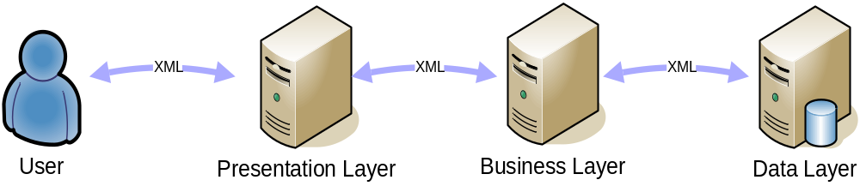

This provides us with the basis for looking at the long term architecture and viability of the Omiga architecture and it is clear that for each tier we may well need to consider different options in order to decide upon an appropriate way forwards.

By breaking down the Omiga architecture in the layers as described above it is possible for us to determine not only an end to end target architecture for the application as a whole but to identify migration options as well. It is this migration work that we need to focus on at this stage as this work could be undertaken as part of a new customer implementation if sufficient planning and technical investigation work has taken place beforehand.

In parallel with the migration work we will continue to work with the other areas of the Vertex Financial Services Division to establish what tools, techniques and components can be re-used.

There is one significant downside to a migration approach as compare to a full re-write and that is that we will have developed a “works with” rather than “designed for” solution. We would not be able to claim use of any of the new features of the .Net 3.0 framework, nor could we easily integrate our application into an enterprise’s Service Oriented Architecture.

The commercial implications of this migration approach is hard to predict – whilst this would probably be an issue for more “technically principled” customers, the majority of RFIs we have seen this year have not drilled down into deep detail on technical implementation suggesting that the business functionality of the Omiga product is the main focus for prospective customers. However, BBG and Nationwide have both been keen to investigate how Omiga could fit into a Service Oriented Architecture approach, and Nationwide have asked questions to a deeper technical level than, say, ING.

Migration Investigation

The migration investigation activity needs to be focussed on reviewing options and routes by which we can maximise our current collateral and move off the VB6 platform whilst maximising the benefits of the .NET development platform and architecture.

There are three areas that need to be investigated as outlined in section 2. These are:
- The Presentation Layer - largely made up of D/HTML code, Jscript and ASP pages.
- The Business Layer – written mainly in VB6 running on COM+ and is reliant on XML
- The Data Layer – mainly stored procedures, triggers and dynamic SQL

In addition there is the Supervisor subsystem which is currently a complete VB6 thick client application. Supervisor has evolved as a single application that maintains different types of data, covering reference data ( e.g. for poplists ), configuration data ( e.g. tasks ) and business application data ( e.g. mortgage products ). Each of these different types of data may well have different target users and it has been discussed that this component would benefit from re-architecting for good business reasons as well as technical ones. A re-implementation of Supervisor as distinct applications written in the appropriate technology ( for example thin client for business data, thick client for reference data ) could be undertaken in parallel with the overall migration as there is minimal interaction between Supervisor and the Omiga application layers.

The remainder of this document outlines more information about the likely options that exist for each area and what benefits the investigation may produce.

The Presentation Layer

This area offers us some simple migration options as much of the actual lines of code contained within this section are not actually written in a language that is being replaced with the roll out of .NET. Our architectural decision to limit the use of ASP (Active Server Pages) means that a port to ASP.NET could be very straight forward and low risk as there are only about 2,500 lines of code to be ported.

Focus for the migration work will be to consider how best to utilise the ASP.NET frameworks.

The Business Layer

Here we find that majority of the VB6 code (approximately 300,000 lines of active code); it is this code that needs to be migrated most as VB6 drops of active support from March 2008. Whilst there are a number of options available to us here, we need to undertake some detailed work to establish whether automated code porting tools could be used and if so to which language (tools are available for porting to VB.NET and C#), C# is our preferred option for new developments.

We have undertaken an evaluation of porting tools and created a cookbook of the manual post-processing steps that we believe need to be undertaken – we have tested this against a very narrow thread of functionality to establish the viability of the produced code to determine whether this could be an effective route. Testing the performance of the ported code has led us to identify the follow technology changes as the bare minimum we currently believe we will need to make –
- Migrate the VB6 code to c#
- Replace use of MSXML4 with System.XML
- Replace use of ADO with ADO.NET

This approach has now been validated on a very small subset of the application.

Discussions have taken place with a third party specialist porting company, Artinsoft, to investigate the possibility of them performing the port. They would achieve this through a combination of (a) using their own automatic conversion tool, the Visual Basic Upgrade Companion, with customisations to suit idiosyncrasies of our code patterns and the specific changes we have requested (e.g. replacing use of MSXML4 with System.XML) and (b) performing a set of manual changes to achieve functional equivalence with the existing VB6 code. This would be followed by a joint exercise to tune the performance of the ported code.

It is expected following the migration certain components / subsystems will benefit from rewriting. We will need to identify these and agree the approach for re-architecting them. For example, Task Manager has a number of issues with its current implementation and would perhaps benefit from being re-architected using the workflow component of the .NET 3.0 framework (Windows Workflow Foundation).

.

Additionally, we will need to investigate the ongoing architecture of Omiga to both efficiently maintain the ported code and to produce new components. Introducing new design patterns and architecture may reduce the amount of code being produced in future, and hence reduce risk

Consideration will also have to be given to the way in which the current Omiga application uses and passes XML between tiers as this may require further changes, possibly to be undertaken as part of the post-migration rearchitecting.

The Data Layer

The area of the architecture is probably the least affected by the advent of .NET, however the move to SQL Server 2005 (Omiga is currently based on SQL 2000) means that we need to migrate this layer in similar timescales as any new Omiga client will want SQL Server 2005 as part of the base implementation. Please note that some work is required to use the new .NET version of SQLOLEDB SQL provider as this is the interconnect between the business and data layers in the current Omiga architecture.

We could also make better use of our own technology in the area of the migration by considering the use of a .NET version of omCRUD (ADOCRUD) which has proven successful in new development projects such as Retail, dramatically reducing the amount of code both in the business and data layers. omCRUD would be amongst the components migrated by Artinsoft. .

Migration Investigation – Resources

There is a need to involve experienced Omiga developers and in particular those with a reasonable level of .NET knowledge. This combination of skills is vital to ensure that the investigation considers not just the technical implications but also the business impact of such a migration.

It is key that we retain focus on the fact that Omiga is a business application albeit one which is highly technical in its construction.

The migration work package will take a copy of the current product version of Omiga and attempt to move each of the layers onto the new target architecture, this activity will include consultancy from Microsoft (already covered within the consultancy budget agreed with Microsoft) and will determine the practicality of the various options.

There can be no absolute guarantees as to the final outcome of a migration of such a large application (Omiga consists of around 1.3 Million lines of code including the Web Site) but Artinsoft have offered a fixed price contract to achieve functional equivalence with the VB6 code.

There is a set of work that must be done to provide Artinsoft with a stable set of code with suitable tests for proving functional equivalence; this work has been documented elsewhere.

Re-architecting components

Whilst it is hoped that a significant proportion of the Omiga code can be migrated, there are some components where there is a strong business case as well as technical case for re-architecting.

Supervisor

The supervisor application has evolved over the years and now addresses the requirements of a variety of different target users.

Reference data needs to be set for the display and behaviour of the application. IT Staff would typically maintain this.

Configuration data needs to be set to control the behaviour of the business processes within Omiga and would typically be set of a mixture of business and IT staff.

Omiga business data ( e.g. Mortgage Products ) is updated and promoted into live use by business users.

Presently all these audiences have to have the thick client application installed onto their environment.

There have been numerous conversations about splitting the supervisor application into distinct areas to be targeted at the appropriate user with the appropriate technology. This work should be done in conjunction with business enhancements around providing support for panel management and, possibly, generic fee sets.

The preferred technology approach would be to re-architect using thin client UI for the business users though the business data has the most complex rules and data assessment so we may need to use thick client with Windows Presentation Foundation deployed through a browser.

This re-architecture would give us the opportunity to develop some of the product using Smart Client or Composite UI Application Blocks - this would allow us to talk about our use of leading edge .NET technology in our product and enable us to engage better with our more technically oriented customers.

Use of Windows Communication Foundation would provide a set of reusable, exposable services that would add to our service catalogue and move us down the path of an SOA architecture.

The current estimate for re-architecting Supervisor is 500 days. This is based on the re-implementation of existing functionality and does not include any business enhancements.

Task Manager

This area has a lot of legacy code that does not need to be ported to .NET. The Task Manager component has evolved with significant amounts of code included that relate to the activities triggered by the tasks ( for example there is code related to performing credit check as opposed to just the code to trigger a credit check when the appropriate task is raised ). There are also versions that differ between ING and DB that will be reconciled as part of the rebaselining of ING.

We are currently evaluating the impact of restructuring this code as it would impact a significant number of components and we would need to define an approach for restructuring these impacted components at the appropriate phase of the migration.

Re-architecting Task Manager to simplify the code and exploit Windows Workflow Foundation would put a key part of .NET 3.0 at the heart of the Omiga product, but may have too great an impact on the rest of the code base.

This investigation and analysis is on-going.

